CS 499 Milestone Two: Software Design and Engineering
Category One Narrative
Judson Hunt

Artifact Description
The artifact selected for this category is an Android inventory app created for CS 360 Mobile Architecture and programming. The application was created and written in Java using Android Studio. In the original app, there were only two simple screens: the login menu and the inventory. The app allowed users to create an account, log in, and manage their personal inventory of items. The inventory screen displayed all the items in a GridLayout, where each row showed the item name, quantity, and increment, decrement, and delete buttons. The app also had SMS capabilities, which would send out a text message whenever an item reached below three. The database was utilizing SQLite with two tables, one for users and one for inventory items. The tables were connected using a foreign key relationship.

Justification for Inclusion
I chose this artifact because it is a perfect starting point for a variety of applications. The application already has many strong points, such as user authentication, small but persistent CRUD capabilities, and a working UI, but the app itself is very lackluster. The foundation of the app made it an ideal candidate to be enhanced and demonstrate my improved software design and engineering skills.
The specific components that showcase software design and engineering skills are the following: first, the original app was completely redesigned from a single screen GridLayout into a multi-screen application using Navigation Components, a BottomNavigationView with five tabs (Library, Books, Movies, Games, and Profile), and a NavHostFragment that manages fragment transactions automatically. This complete restructuring demonstrates a solid understanding of Android application architecture, the separation of concerns principle (each screen acts as an independent Fragment with its own layout and logic), and the importance of proper modularization and containerization. Second, the flay GridLayout was replaced with a RecyclerView that’s backed by a custom MediaItemAdapter, which uses the ViewHolder to efficiently recycle card views as the user scrolls. This significantly improves over the original approach, which destroyed and recreated every row on every data change. Third, the app was expanded from a single-category inventory to a three-category media library supporting books, movies, and games. Each item can now record the title, category, year, rating, and notes. Fourth, the UI was updated to use Material Design components, including MaterialCardView, FloatingActionButton, and consistent color theming. This change resulted in a much more polished and professional appearance.

Course Outcomes
The planned enhancement for category one targeted course outcome number four: demonstrate an ability to use well-founded and innovative techniques, skills, and tools in computing practices for the purpose of implementing computer solutions that deliver value and accomplish industry-specific goals (software engineering/design/database). This outcome was met through implementation of industry-standard Android architecture such as Navigation Components, Fragment lifecycle management, RecycleView with ViewHolder, and Material Design components.

Process Reflection
The process of enhancing this artifact reinforced several important lessons about software design. For example, the importance of properly implementing containerization and modularization can separate amateur apps from professional. One significant challenge came from transitioning to the Navigation Component with the BottomNavigationView. The ViewPager2 and TabLayout serve a similar function, but when mixing the two, it causes conflicts and bugs, especially when running the app on different devices. This upgrade required an entire rewrite of the LibraryMain class. The RecyclerView and adapter were also great learning experiences. The original GridLayout approach rebuilt the entire list from scratch anytime there was a change in data, which would not scale well at all. Implementing the MediaItemAdapter with the ViewHolder required more planning and thinking out the relationship between the data model and the view layer. This shifts the thinking from “rebuild everything” to “update only what changed” and will result in a better performing application. Overall, the enhancement process transformed a functional single-screen inventory app into a well-structured, extensible media library application that demonstrates professional Android development skills. The challenges faced only honed my skills further.

Photographic Evidence
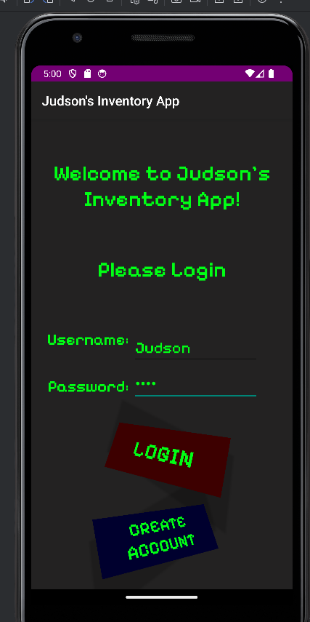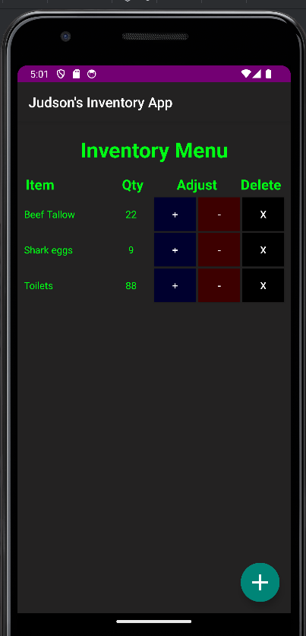
Above is the artifact app that was chosen. On the left is the simple login menu. On the right is the inventory menu, displaying example items.

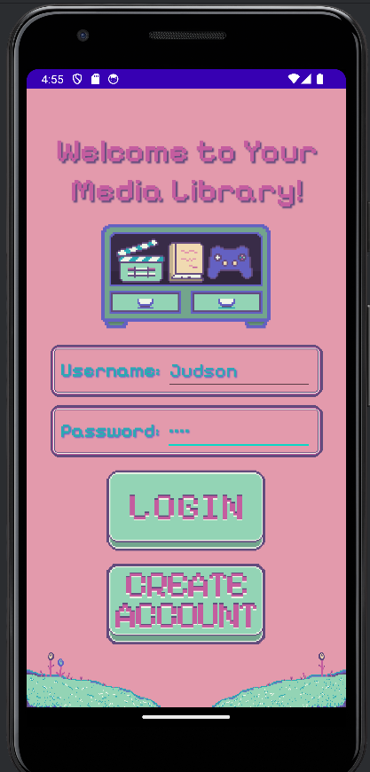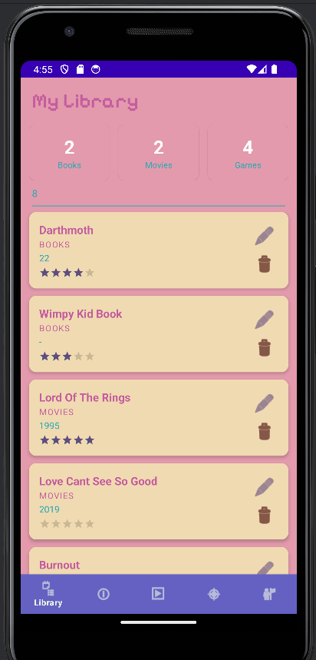
Above is the enhanced application. On the left is the newly updated login menu. On the right is the default library tab. This will display all items in the user’s library, from all categories. The bottom navigation bar displays all menus available to the user (Library, Books, Movies, Games, and Profile)

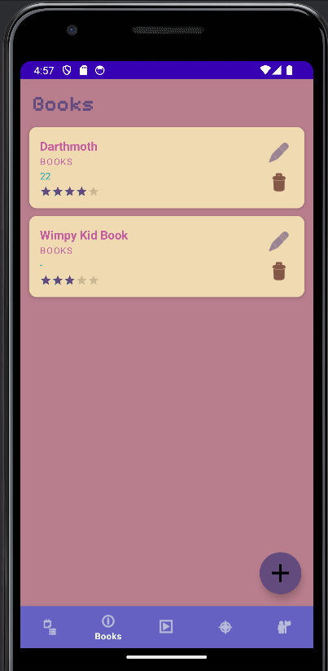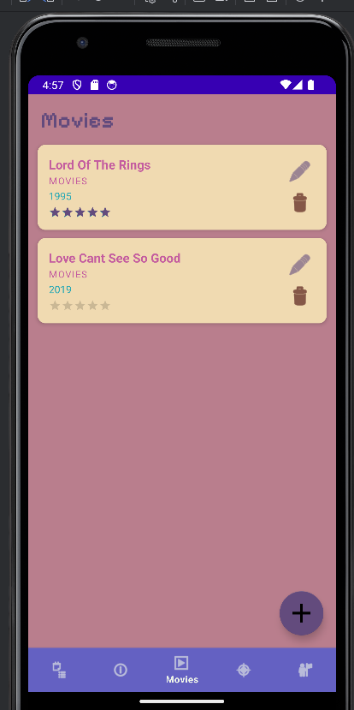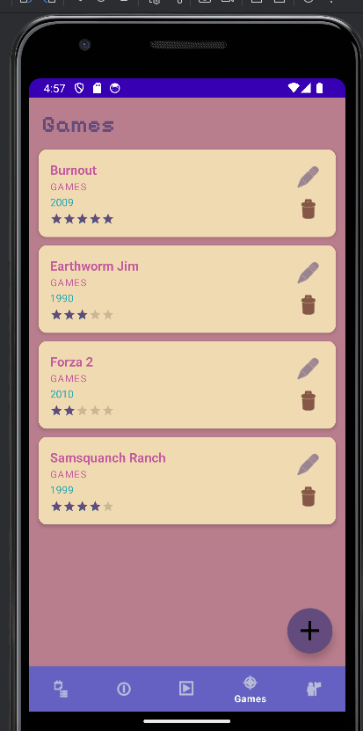
Above are the three main categories for the multi-media library, books, movies, and games. The FAB button at the bottom right will open a small add item menu that will add the new item to the respective category that is open.

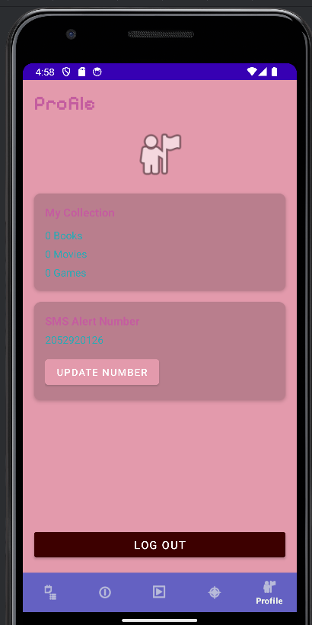
Lastly, above is the profile tab. This will display the user’s information, text alert status, and allows users to log out. The SMS capabilities are not necessary for this app and will be removed if no implementation has been discovered.

